Pollution Incident Response
Management Plan (PIRMP)

Hume Power Station

Version 5
December 2022

Revision History
Date | Version | Prepared By | Amendments
31 October 2014 | 1.0 | Nicola Foran | Updated various sections to reflect change in licence holder
17 July 2015 | 2.0 | Nicola Foran | Updates various sections to include additional detail resulting from EPA Audit.
21 October 2016 | 3.0 | Nicola Foran | Minor amendments to reflect changes in terminology.
10 August 2018 | 4.0 | Shaun Coffey | Updated various sections to reflect change in parent company and general administrative and formatting changes.
14 November 2018 | 4.1 | Shaun Coffey | Added sections 3 and 4 and made minor administrative changes.
25 June 2019 | 4.2 | Shaun Coffey | Review following oil spill event
16 December 2022 | 5.0 | Chris Baldwin | Updated to Foresight Group / Peak Renewables. Section 4 and 5 updated.

Introduction
This Pollution Incident Response Management Plan (‘PIRMP’) has been developed in accordance with Chapter 7, Part 3A of the Protection of the Environment Operations (General) Regulations 2009, hereafter referred to as the Regulations.
One of the requirements of the Regulations is that PIRMPs be prepared by the holders of Environment Protection Licenses in relation to the activities carried out under such Licenses. In particular, it specifies the additional information that is required in a plan, the manner in which it is to be made available to stakeholders and the occasions on which it is to be tested.
This PIRMP is for GSP Energy Pty Ltd’s (‘GSP Energy’) Hume Power Station which holds Environmental Protection License 10675. The PIRMP references GSP Energy’s existing documentation and provides a summary outlining how the existing documentation satisfies each requirement in the Regulations.

PIRMP Reference Table
The table below summarises how GSP Energy is meeting the requirements of the Regulations, and provides references for relevant documentation.
Clause Number | Requirements | GSP Energy Compliance Assessment
98B | Form of Plan  - A plan is to be in written form.  - A plan may form part of another document that is required to be prepared under or in accordance with any other law so long as the information required to be included in the plan is readily identifiable as such in that other document. | This document will be the PIRMP.  This table references existing documentation to satisfy the requirements.
98C (note) | Additional matters to be included in plan  The note refers to Section 153C (a-c) of the Protection of the Environment Operations Act 1997 (the Act). The plan must include the following:
 | 153C (a)  The procedures to be followed in notifying a pollution incident to:  - Owners or occupiers of premises in the vicinity; and  - The local authority; and  - Persons or authorities required to be notified by Part 5.7 of the Act. | Section 9.3 of the Hume Emergency Response Plan details contact numbers of adjacent facilities.  Section 3.2 of the PIRMP details contact numbers for local authorities and authorities required to be notified by Part 5.7.  The Pollution Incident Response Flow Chart in Section 4 of the PIRMP gives contact details for EPA, Emergency Services and the local Council.
 | 153C (b)  Detailed description of actions to be taken immediately after a pollution incident, to reduce or control pollution. | Section 7 of the Hume Emergency Response Plan gives an overview of the emergency response process at the site. The Pollution Incident Response Flow Chart (Appendix J) gives more specific detail on pollution incident responses.
 | 153C (c)  Procedures for co-ordinating with authorities any action in combating the pollution caused by the incident, and the persons through whom all communications are to be made. | Section 9.3 of the Hume Emergency Response Plan details contact numbers of adjacent facilities.  Section 3.2 of the PIRMP details contact numbers for local authorities and authorities required to be notified by Part 5.7.  The Hume Emergency Response Plan details procedures for coordinating with authorities, dealing with pollution and communication protocols.
98C | Additional matters to be included in plan  - General  The matters required under section 153C (d) of the Act to be included in a plan are as follows:
 | - a description of the hazards to human health or the environment associated with the activity to which the licence relates (the relevant activity) | The Environmental Risk Register in Section 6 of the PIRMP lists the hazards to human health and the environment relating to the relevant activity.
 | - the likelihood of any such hazards occurring, including details of any conditions or events that could, or would increase that likelihood | The Environmental Risk Register in Section 6 of the PIRMP lists the conditions and events that could result in hazards to human health and the environment.
 | - details of the pre-emptive action to be taken to minimise or prevent any risk of harm to human health or the environment arising out of the relevant activity | The Environmental Risk Register in Section 6 of the PIRMP lists the pre-emptive control measures which have been implemented to minimise the risks to human health and the environment.
 | - an inventory of potential pollutants on the premises or used in carrying out the relevant activity | Section 3.4 of the PIRMP lists the possible sources of pollution including substance(s), location and quantity.
 | - the maximum quantity of any pollutant that is likely to be stored or held at particular locations (including underground tanks) at or on the premises to which the licence relates | See (d) above.
 | - a description of the safety equipment or other devices that are used to minimise the risks to human health or the environment and to contain or control a pollution incident | Appendix E of the Hume Emergency Response Plan lists safety and environment emergency response equipment.
 | - the names, positions and 24-hour contact details of those key individuals who:  - are responsible for activating the plan; and  - are authorised to notify relevant authorities under section 148 of the Act; and  - are responsible for managing the response to a pollution incident. | Section 7 of the Hume Emergency Response Plan states that the Hydro Operations Manager is the Chief Warden. Therefore, this person is responsible for activating the plan and managing the response to a pollution incident.  Section 9.2 of the Hume Emergency Response Plan lists contact details for all site staff and various senior staff that may be of assistance for emergency response.  Section 3.2 of the PIRMP gives details of notification of external authorities (including the EPA).
 | - the contact details of each relevant authority referred to in section 148 of the Act | Section 3.2 of the PIRMP details contact numbers for authorities required to be notified under Section 148 of the Act.
 | - details of the mechanisms for providing early warnings and regular updates to the owners and occupiers of premises in the vicinity of the premises to which the licence relates or where the scheduled activity is carried on. | Section 9.3 of the Hume Emergency Response Plan details the mechanisms for notifying the adjacent facilities.
 | - the arrangements for minimising the risk of harm to any persons who are on the premises or who are present where the scheduled activity is being carried on | Sections 11, 12 and 13 of the Hume Emergency Response Plan detail Rescue, First Aid and Evacuation procedures.
 | - a detailed map (or set of maps) showing the location of the premises to which the licence relates, the surrounding area that is likely to be affected by a pollution incident, the location of potential pollutants on the premises and the location of any stormwater drains on the premises | Appendix G of the Hume Emergency Response Plan contains maps of areas relevant to incident response.  SDS and location maps are located in repositories around site in the vicinity of potential pollutants.
 | - a detailed description of how any identified risk of harm to human health will be reduced, including (as a minimum) by means of early warnings, updates and the action to be taken during or immediately after a pollution incident to reduce that risk. | Section 7 of the Hume Emergency Response Plan details the Emergency Response Procedure. Appendices I and K of the Hume Emergency Response Plan details the Emergency Response Scenarios, and the procedures for managing these.
 | - the nature and objectives of any staff training program in relation to the plan | Section 20 of the Hume Emergency Response Plan details the nature and objectives of training for staff.
 | - the dates on which the plan has been tested and the name of the person who carried out the test | Section 5.1 of the PIRMP includes this information.
 | - the dates on which the plan is updated | The revision history on page 2 of the PIRMP includes this information.  Section 18.1 of the Hume Emergency Response Plan lists the timeframes for updates to various sections of the Hume Emergency Response Plan.
 | - the manner in which the plan is to be tested and maintained | Section 5.1 of the PIRMP includes this information.  Section 18.1 of the Hume Emergency Response Plan lists the timeframes for updates to various sections of the Hume Emergency Response Plan and Section 19 details the test frequency for the Plan.
98D | Availability of plan  - A plan is to be made readily available:  - to an authorised officer on request; and  - at the premises to which the relevant licence relates, or where the relevant activity takes place, to any person who is responsible for implementing the plan | The PIRMP is available on the Peak Renewables (on behalf of GSP Energy) website.  Hard copies of the PIRMP are located within the Hume Power Station and Site Office.
 | - A plan is also to be made publicly available in the following manner within 14 days after it is prepared:  - in a prominent position on a publicly accessible website of the person who is required to prepare the plan  - if the person does not have such a website – by providing a copy of the plan, without charge, to any person who makes a written request for a copy | The PIRMP is available on the Peak Renewables (on behalf of GSP Energy) website.
 | - Subclause (2) applies only in relation to that part of a plan that includes the information required under:  - section 153C (a) of the Act, and  - clause 98C (1) (h) and (i) or (2) (b) and (c) (as the case requires) | The full PIRMP has been made available on the Peak Renewables (on behalf of GSP Energy) website.
 | - Any personal information within the meaning of the Privacy and Personal Information Protection Act 1998 is not required to be included in a plan that is made available to any person other than a person referred to in subclause (1). | The PIRMP is publicly available. Personal information will not be included in the PIRMP.
98E | Testing of Plan  - The testing of a plan is to be carried out in such a manner as to ensure that the information included in the plan is accurate and up to date and the plan is capable of being implemented in a workable and effective manner.  - Any such test is to be carried out:  - routinely at least once every 12 months; and  - within one month of any pollution incident occurring in the course of an activity to which the licence relates so as to assess, in the light of that incident, whether the information included in the plan is accurate and up to date and the plan is still capable of being implemented in a workable and effective manner. | Section 5 of the PIRMP and Section 19 of the Hume Emergency Response Plan outline the testing requirements.

Pollution Incident Response and Notification
Under the Protection of the Environment Operations Act 1997 (POEO Act), a pollution incident means an incident or set of circumstances during or as a consequence of which there is or is likely to be a leak, spill or other escape or deposit of a substance, as a result of which pollution has occurred, is occurring or is likely to occur. It includes an incident or set of circumstances in which a substance has been placed or disposed of on premises, but it does not include an incident or set of circumstances involving only the emission of any noise.

  - Duty to Notify
Under the POEO Act, the following people have a duty to notify a pollution incident occurring in the course of an activity that causes or threatens material harm to the environment:
- an employee carrying on the activity relating to the pollution incident
- an employer after becoming aware of a pollution incident
- the occupier of the premises where the pollution incident occurs.
Notification must be given immediately, i.e. promptly and without delay, after the person becomes aware of the incident.
You do not have to report if you know that all relevant authorities have already been notified. ‘Relevant Authority’ means:
- the appropriate regulatory authority (ARA)
- the Environment Protection Authority (EPA) if they are not the ARA
- the Ministry of Health
- SafeWork NSW
- Fire and Rescue NSW.
Refer to Section 14.2 for contact details.

  - Pollution Incident External Authority Notification
After a Pollution Incident the Chief Warden is responsible to ensure that the relevant authorities have been notified.
External Authority | Contact Number
Environmental Protection Authority (EPA) | 131 555
Fire and Rescue NSW | 000
Albury City Council | 02 6023 8111
SafeWork NSW | 13 10 50
SES Albury | 02 6058 5300
NSW Ambulance | 000
NSW Police | 000
WaterNSW (Hume) | (02) 6026 4332 – Duty Officer
Ministry of Health – ask for Public Health Officer | 1300 066 055
NSW National Parks and Wildlife | 1300 361 967
NSW Office of Environment and Heritage | 131 555

  - Pollution Incident Response
In the event of a Pollution Incident from the Power Station or its associated plant the flow chart outlined in Appendix J should be applied.

  - Possible Sources of Pollution
Store | Location | Substance(s) | Quantity (litres)
2 x 11kV/66kV/132kV transformers | Switchyard | Transformer Oil (FR3 Vegetable Based) | 43,500 each
2 x unit governor systems | Power Station | Hydraulic Oil | 7,000 each
2 x unit generator bearing systems | Power Station | Lubricating Oil | 6,680 each
2 x 11kV/415V auxiliary transformers | Switchyard | Transformer Oil | 1,200 each
2 x turbine bearing systems | Power Station | Lubricating Oil | 1,000 each
2 x main intake gates | Dam Wall | Hydraulic Oil | 750 each
Standby generator | Power Station | Diesel | 600
Mobile diesel pump | Mobile | Diesel | 450
Miscellaneous oils, lubricants, flammables, etc. | Power Station | Various | <200

Pollution Incident Response Flow Chart

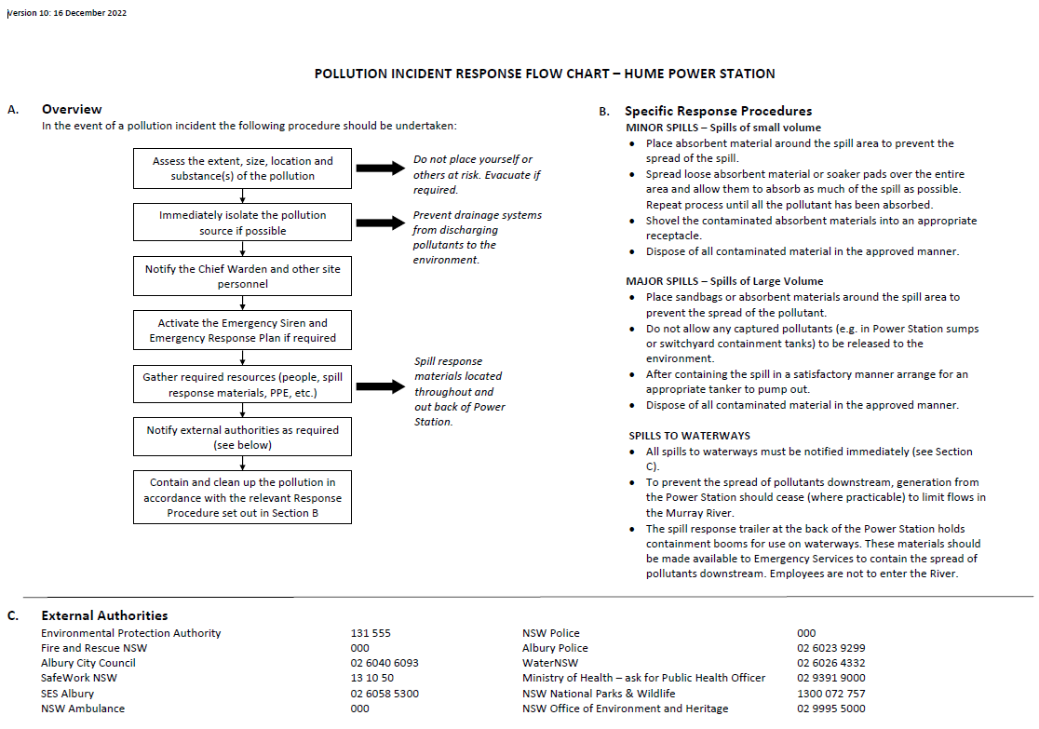

Testing Requirements for the PIRMP
Testing of the PIRMP is required to be undertaken once annually during the Annual Return period, being 1st November to 31st October. The testing can either be undertaken as a desktop simulation, practical exercises or drills.
Practical exercises and drills should be undertaken as part of the testing of the Hume Emergency Response Plan.
Desktop simulations should involve checking that the details in the PIRMP are sufficient to meet the requirements of the Act and Regulations and that the cross references to the Hume Emergency Response Plan are accurate. The Hume Emergency Response Plan should also be checked at the same time, to insure information is correct, particularly around staff personnel and roles, and contact phones numbers. A desktop simulation should also involve physically ringing some phone numbers to ensure that they work and that correct and appropriate people can be contacted through those numbers.
This PIRMP is also required to be tested within one month of any pollution incident occurring. In light of that incident, the PIRMP should be tested to confirm that the information included in the PIRMP is still accurate and up to date, and that the plan is capable of being implemented in a workable and effective manner.

Plan Test History
Date | Conducted By | Test Type | Recommendations | Test Due Date
9 – 13 October 2014 | Nicola Foran | Desktop Simulation | Updated various sections to reflect change in licence holder | September 2015 (Practical Exercise)
28 June –17 July 2015 | Nicola Foran | Desktop Simulation | Update various sections to include additional detail. | August 2015 (Practical Exercise)
23 September 2015 | Robert Sigmund | Practical Exercise | In conjunction with testing of the Hume Emergency Response Plan. No changes required. | September 2016 (Desk Top Simulation)
21 October 2016 | Nicola Foran & Julz Lawrence | Desktop Simulation |  | March 2017 (Practical Exercise)
18 October 2017 | Thurgoona Training Academy | Practical Exercise | In conjunction with testing of the Hume Emergency Response Plan. No changes required. | Prior to 31 October 2018
28 August 2018 | Thurgoona Training Academy | Practical Exercise | In conjunction with Warden training | Prior to 31 October 2019
25 June 2019 | Shaun Coffey | Desktop Simulation | Reviewed all content following recent oil spill event | Prior to 31 October 2020
Date | Conducted By | Test Type | Recommendations | Test Due Date
10th July 2021 | Hume site operations team | Practical Exercise | No changes required. | Prior to 31 October 2021
2nd August 2022 | GSP operations team | Practical Exercise | No changes required. | Prior to 31 October 2022

Environmental Risk Register
Activity / Apparatus | Risk | Substance(s) | Impacts | Control Measures
Switchyard transformers | Transformer cooling water contaminated with oil leading to pollution of waters | Oil | Compliance  Lane  Water  Reputation | Transformer design  Gravel in pit  Inspections  Primary and secondary containment systems  EPA Licence monitoring requirements
 | Transformer leak | Oil | Compliance  Land  Water  Reputation | Alarms  Bunding  Primary and secondary containment systems  Regular routine inspections
 | Transformer explosion and fire | Oil | Air  Compliance  Financial implications  Health and Safety  Land  Reputation  Water | Gravel in pits  Hume Emergency Response Plan  Explosion walls  Routine checks for leaks  Maintenance procedures  Primary and secondary containment systems  Transformer design
General Contractor activities | Contractor undertaking an activity which causes an environmental impact | Various | Air  Compliance  Flora and fauna  Health and safety  Land  Reputation  Water | Contractor contracts and clauses  Contractor management by GSP Energy staff  Supervision  Risk assessment process  Site induction
Compliance with EPA Licence | Breach of licence conditions | Oils  Particulates | Compliance  Land  Reputation  Water  Financial implications | Modification of secondary containment system to minimise risk of external impact  Compliance audits  Policies and procedures  Routine inspections  EPA Licence monitoring requirements  Training
 | Failure of systems (e.g. separation and containment systems) leading to an externally reportable incident | Oil | Compliance  Land  Reputation  Water  Financial implications | Alarms for instrument failure  Backup instruments operational  Bunding  Contaminated water system  Drains to contaminated water pits  Emergency response  Routine inspections  Oil / water separator  Training
Hume Power Station Operations | Fire in Hume Power Station | Oil  Particulates  Smoke | Air  Compliance  Financial Implications  Reputation  Water | Automatic fire suppression systems  Hume Emergency Response Plan  Water mist system  Monthly inspections of fire suppression and alarm systems
 | Oil releases within Hume Power Station not contained therefore impacting on river | Oil | Compliance  Financial Implications  Flora and Fauna  Reputation  Water | Oil spill materials available throughout Hume Power Station  Training  Drainage pit  Oil escape detectors  Routine checks & restocking skimmers monthly
 | Turbine failure results in uncontrollable release of oil | Oil | Compliance  Financial Implications  Flora and Fauna  Reputation  Water | Routine inspections by GSP Energy staff  Local / specialised understanding of the system (risk)  Oil spill materials available throughout Hume Power Station  Training
Weed Management | Inadequate weed control resulting in breach of Noxious Weeds Act | Noxious weeds | Compliance  Flora and Fauna | Training  Appropriate weed control practices
Mercury Switches | Mercury Spill | Mercury | Compliance  Health and Safety  Water  Reputation | Oil spill materials available throughout Hume Power Station  Specific mercury spill kit available in Hume Power Station  Hume Emergency Response Plan

